Report on the Darcy-Weisbach Equation

The Darcy-Weisbach equation defies an empirical relationship between head loss or pressure loss due to friction along a given length of pipe and the average velocity of the fluid flow for an incompressible fluid. The calculation of the hydraulic friction factor in this equation depends on the surface of the pipe wall, and the flow mode of the liquid variables that can be defined by the roughness height per unit internal diameter $\left(\frac{k_{e}}{d_{int}}\right)$ and the Reynolds Number (Re) respectively.

**Forms of the Darcy-Weisbach equation**

The head loss expresses the pressure loss due to friction in terms of the equivalent height of column of the working fluid, so that the pressure drop is…

$$Δp=ρgΔh$$

The head loss ($ΔH$) of a pipe would be defined as

$$ΔH=\left(f\frac{l}{d_{int}}+\sum{ξ} \right)\frac{v^{2}}{2g}$$

l=length of pipe (m), $d_{int}$ =inner pipe diameter (m), $\sum{ξ}$ = sum of minor loss coefficients, v= velocity of fluid (m/s)), g = gravitational acceleration m/s^2.

**Pressure Loss Form**

$$Δp=ξ\frac{L}{D}\left(\frac{ρ∙u^{2}}{2}\right)$$

$Δp$ (Pa) is the total pressure loss due to friction

$ξ$ is a friction factor co-efficient

L(m) is the length of pipe

D(m) is the pipe internal diameter

$u$ (m/s) is the average fluid velocity

$ρ(kg/m^{3})$ is the fluid density

“Reynolds numbers below 200 to 2100 correspond to laminar or viscous flow; numbers from 2000 to 3000 to 4000 correspond to a transition region of peculiar flow, and numbers above 4000 correspond to turbulent flow”

**Laminar Regime**

In the laminar regime the flow of the fluid is defined by **Poiseuille’s law**

$$f=\frac{64}{Re}$$

Where the Reynold’s Number is defined as

$$Re=\frac{ρ}{μ}〈v〉D$$

Where $ρ$ is the density of the fluid, $μ$ is the dynamic viscosity of the fluid (kg/(ms)), <v> is the mean flow velocity, which would be measured experimentally as the volumetric flow rate Q per unit cross sectional wetted area and D is the characteristic length.

$$ν=\frac{μ}{ρ}$$

Laminar flow exists when the Reynold’s Number Re < 2000. Friction loss arises from the transfer of momentum from the fluid in the centre of the flow to the pipe wall via the viscosity of the fluid. As the flow is laminar there are no vortices present in the flow. Also because the friction loss is proportional to the flow velocity rather than proportional to the square of the velocity, one can regard the Darcy-Weisbach equation as not applying.

**Turbulent Regimes**

For wholly turbulent flow, where the Reynold’s number is relatively large, the friction factor is independent of the Reynold’s number and is a function of relative roughness only. Between laminar flow and wholly turbulent flow the friction factor depends on both the Reynold’s Number and the relative roughness. The Moody Diagram is an accepted method to calculate the friction factor resulting in pipes and other closed contacts (Glenn O. Brown)

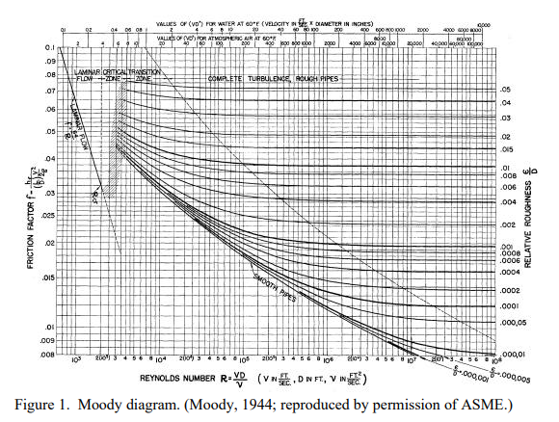

For the entire turbulent flow range, friction factors can be read from a Moody chart or can be calculated using the **Colebrook formula**.

$$\frac{1}{\sqrt{f}}=2log⁡(\frac{k_{e}.}{3.7d_{int}}+\frac{2.52}{Re\sqrt{f}})$$

Which is an empirical fit of the pipe flow data. For hydraulically smooth ($k_{e}=0$) pipe the friction factor is given by the **Blasius formula**

$$f=\frac{0.316}{Re^{\frac{1}{4}}}$$

For hydraulically smooth pipes **Prantl (1932)** proposed the formula

$$\frac{1}{\sqrt{f}}=2\log\left(Re\sqrt{f}\right)-0.8$$

But when $Re≥{10}^{4}$ the **Altshul Equation** can be used

$$f=\frac{1}{{\left(1.82\log\left(Re\right)-1.64\right)}^{2}}$$

**Nikuradse Equation $Re≥{10}^{5}$**

$$f=0.0032+\frac{0.2211}{Re^{0.237}}$$

For smooth and rough pipes when Re>4000 in which the pipes are flowing completely full of liquid then the **Colebrook-White Equation** is used

$$\frac{1}{\sqrt{f}}=2\log\left(\frac{k_{e}.}{3.7d_{int}}+\frac{2.52}{Re\sqrt{f}}\right)$$

This equation can either be solved explicitly using the Lambert W equation or numerically by composing approximation formulas.

[Introducing Thermal Systems]

Determining the Hydraulic Friction Factor in Pipeline Systems Summary

**Research approach**

The main goal of this paper was to mathematically model λ in the critical zone by building an interpolation between laminar flow and turbulent flow to ensure a smooth and continuous function. The list of these formulas are given in the Formula list section.

**Results: Accuracy**

A comparison between existing formulas for the Darcy friction factor was carried out. Values of hydraulic friction factors calculated by a range of formulas were substituted into the Colebrook-White equation, and absolute mean square deviation is shown in a series of plots. The **Clamond method** shows the lowest deviation (highest accuracy) for all ranges of (k\_e/d\_int) and the **Goudar and Sonnad** method comes second. This method is almost identical for the smooth pipes zone and gives almost identical accuracy for slightly rougher pipes. The Clamond and Goudar-Sonnad methods give better accuracy than other researched formulas.

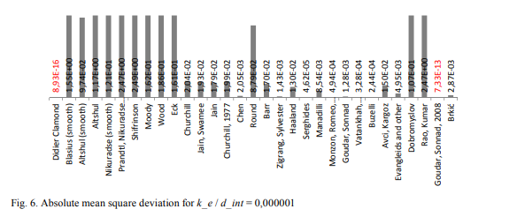**Results: Time**

Relative CPU time was compared measured using the timer() function of SciLab in which all functions had been coded for. The results are given in the graph below.

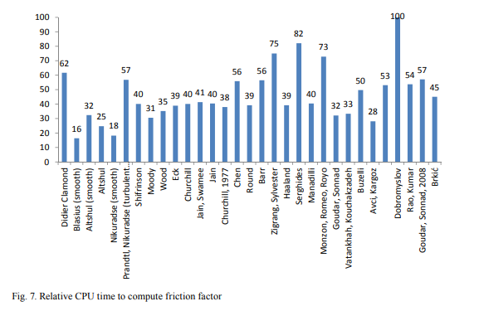

**Results: Relative Deviation**

Relative Deviation was calculated from all formulas compared to the results from the Clamond method using the formula $\left(\frac{λ_{i}-{λ }_{Clamond}}{λ_{Clamond}}\right)×100\%$ ove $k_{e}/d_{int}$ values of 0.000001;0.0001,0.001,0.01,0.05. After plotting graphs that highlight the behaviour of different equations for the friction factor, a clearer set of criteria for considering accuracy was established. This would be measurements representing the mean square deviation of results from the ideal (Clamond solution). These calculations are represented in graphs in the paper like the one below showing in most cases that the Goudar-Sonnad has the least deviation across the range of $k_{e}/d_{int}$.

**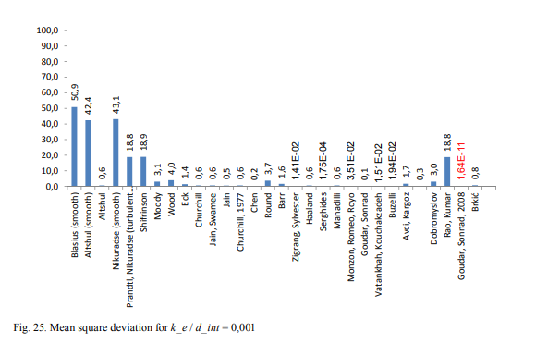**

One way to describe lambda in critical zone is to build cubic interpolation function. There is widely adopted cubic interpolation developed by Dunlop. He took the Poiseuille equation for laminar flow and Swamee-and-Jain equation for turbulent flow as boundary conditions. In order to provide smooth transition from laminar regime to turbulent using more accurate solution of Colebrook-White equation given by Clamond, a general cubic interpolation polonomial is proposed, which allows setting any functions as boundary conditions.

The General cubic interpolation polynomial is given by:

$$f_{cab\left(x\right)}=a{\left(x-x_{1}\right)}^{3}+b{\left(x-x_{1}\right)}^{2}+c\left(x-x_{1}\right)+d=0$$

And at the boundary points of the region x\_1 and x\_2 you can define a set of equation terms:

$$\left\{\begin{aligned}f_{cub}\left(x_{1}\right)=f_{1}\left(x_{1}\right), \\ f_{cub}\left(x_{2}\right)=f_{1}\left(x_{2}\right), \\ {f'}_{cub}\left(x_{1}\right)=f_{1}'\left(x_{1}\right), \\ {f'}_{cub}\left(x_{2}\right)=f_{2}'\left(x_{2}\right),\end{aligned}\right.$$

Solving these systems of equations to identify coefficients can be done using numerical differentiation.

$$a=-\frac{\left(2f_{2}\left(x_{2}\right)-f_{1}\left(x_{1}\right)\right)-\left({f^{'}}_{2}\left(x_{2}\right)+f^{'}\left(x_{1}\right)\right)\left(x_{2}-x_{1}\right)}{{\left(x_{2}-x_{1}\right)}^{3}}$$

$$b=-\frac{\left(3f_{2}\left(x_{2}\right)-f_{1}\left(x_{1}\right)\right)-\left({f^{'}}_{2}\left(x_{2}\right)+f^{'}\left(x_{1}\right)\right)\left(x_{2}-x_{1}\right)}{{\left(x_{2}-x_{1}\right)}^{2}}$$

$$c={f'}_{1}\left(x_{1}\right)$$

$$d=f_{1}\left(x_{1}\right)$$

As the differentials can be computed numerically.

$$f^{'}\left(x\right)=\frac{f\left(x+Δx\right)-f\left(x\right)}{Δx}$$

It is widely accepted in hydraulic calculations that critical zone lays in 2000 < Re< 4000, which is why $x_{1} =2000, x_{2}=4000$.

**Author’s summary**

“Method of Clamond to solve Colebrook-White equations clearly sets aside from other methods because of its constant highly accurate results for all ranges of Reynolds number and k\_e / d\_int. We propose easy to use algorithm of cubic interpolation for critical zone, which provides smooth transition and allows using any chosen functions as boundary.”

# **The simple cubic interpolation in the critical phase derivation.**

This formula will link laminar flow to turbulent flow with a simple cubic formula. It take account of the continuity of the flow by setting the first value of the critical flow to the final value of the laminar flow (at Re = 2000) and the last value of the critical zone flow to the first value of the turbulent flow (at Re = 4000).

It assumes that there is a turning point between laminar flow and critical phase, and a turning point between the critical phase and the turbulent flow.

This flow is independent is also assumed to be independent of any other obvious variable than the Reynold’s Number.

The Darcy friction value of the flow of the critical phase is modelled by a cubic polynomial $f_{critical}=ax^{3}+bx^{2}+cx+d$ where x is the change in the Reynolds number of the flow from the Reynold’s number at end of the laminar phase and start of the critical phase is given by $Re_{c},$ where $Re_{c}≈2000$.

$$f_{critical}(Re)=a{(Re-Re_{c})}^{3}+b{(Re-{Re}_{c})}^{2}+c(Re-{Re}_{c})+d$$

The co-efficient d is determined by the boundary condition that the flow at the laminar phase is continuous in the critical phase.

$$f_{laminar}\left(Re_{c}\right)=f_{critical}\left(Re_{c}\right)=f_{critical}\left(0\right)=a{(0)}^{3}+b{(0)}^{2}+c(0)+d$$

$$d=f_{laminar}\left(Re_{c}\right)=L$$

The co-efficient c is determined by the saddle point condition that the flow at the laminar phase changes immediately into the critical phase.

$$f_{laminar}^{'}\left(Re_{c}\right)=f_{critical}^{'}\left(Re_{c}\right)=f_{critical}^{'}\left(0\right)=3a{(0)}^{2}+b\left(0\right)+c=0$$

$$c=0$$

The next boundary condition to consider is that the flow at the critical phase is continuous in the turbulent phase. The Reynold’s number at start of the turbulent phase is given by $Re_{t},$ where $Re_{t}≈4000$

$$f_{turbulent}\left(Re_{t}\right)=f_{critical}\left(Re_{t}\right)=a{(Re_{t}-Re_{c})}^{3}+b{(Re_{t}-Re_{c})}^{2}+c(Re_{t}-Re_{c})+d$$

$$f_{turbulent}\left(Re_{t}\right)=a{(Re_{t}-Re_{c})}^{3}+b{(Re_{t}-Re_{c})}^{2}+ f_{laminar}\left(Re_{t}-Re_{c}\right)$$

$$f_{turbulent}\left(Re_{t}\right)=T and f_{laminar}\left(Re_{c}\right)=L$$

$$T=a{(Re_{t}-Re_{c})}^{3}+b{(Re_{t}-Re_{c})}^{2}+ L$$

Using the assumption that the flow between the critical phase and the turbulent phase also represents a local turning point

$$f_{turbulent}^{'}\left(Re_{t}\right)=f_{critical}^{'}\left(Re_{t}-Re_{c}\right)=3a{(Re_{t}-Re_{c})}^{2}+2b\left(Re_{t}-Re_{c}\right)+c=0$$

$$3a{(Re_{t}-Re_{c})}^{2}+2b\left(Re_{t}-Re_{c}\right)=0$$

$$b=\frac{3a{\left(Re_{t}-Re_{c}\right)}^{2}}{2\left(Re_{t}-Re_{c}\right)}=\frac{3a}{2}\left(Re_{t}-Re_{c}\right)$$

$$or a=\frac{2b\left(Re_{t}-Re_{c}\right)}{3{\left(Re_{t}-Re_{c}\right)}^{2}}= \frac{2b}{3(Re_{t}-Re_{c})}$$

Now you can substitute $b=\frac{3a}{2}\left(Re_{t}-Re_{c}\right)$ into $T=a{(Re_{t}-Re_{c})}^{3}+b{(Re_{t}-Re_{c})}^{2}+ L$

$$T=a{(Re_{t}-Re_{c})}^{3}+\frac{3a}{2}\left(Re_{t}-Re_{c}\right)∙{(Re_{t}-Re_{c})}^{2}+ L$$

$$\frac{5a}{2}{\left(Re_{t}-Re_{c}\right)}^{3}=(T-L)$$

$$a=\frac{2}{5}∙\frac{T-L}{{\left(Re_{t}-Re_{c}\right)}^{3}}$$

$$b=\frac{3}{2}∙\frac{2}{5}∙\frac{T-L}{{\left(Re_{t}-Re_{c}\right)}^{3}}∙\left(Re_{t}-Re_{c}\right)=\frac{3}{5}∙\frac{T-L}{{\left(Re_{t}-Re_{c}\right)}^{2}}$$

So the equation for the critical flow becomes

$$f_{critical}=a{\left(Re-Re_{c}\right)}^{3}+b{\left(Re-Re_{c}\right)}^{2}+cx+d$$

$$f_{critical}=\frac{2}{5}∙\frac{T-L}{{\left(Re_{t}-Re_{c}\right)}^{3}}{\left(Re-Re_{c}\right)}^{3}+\frac{3}{5}∙\frac{T-L}{{\left(Re_{t}-Re_{c}\right)}^{2}}{\left(Re-Re_{c}\right)}^{2}+L$$

Where

$$f_{turbulent}\left(Re_{t}\right)=T and f_{laminar}\left(Re_{c}\right)=L$$

$$f_{critical}=\frac{2}{5}∙\frac{f_{turbulent}\left(Re_{t}\right)- f_{laminar}\left(Re_{c}\right)}{{\left(Re_{t}-Re_{c}\right)}^{3}}{\left(Re-Re_{c}\right)}^{3}+\frac{3}{5}∙\frac{f_{turbulent}\left(Re_{t}\right)- f_{laminar}\left(Re_{c}\right)}{{\left(Re_{t}-Re_{c}\right)}^{2}}{\left(Re-Re_{c}\right)}^{2}+ f_{laminar}\left(Re_{c}\right)$$

The tests will be carried out initially with the Clamond Method initially but then I will carry out some tests with other methods that are listed in the Appendix.

**Clamond Method**

Didier Clamond allows an iterative calculation of $λ$, which gives accuracy close to the limits of type double after two iterations. If requires calculation of logarithm once for initial estimation and one time per iteration.

$$f=F^{2}$$

Where

$$K=\frac{k_{e}}{d_{int}}$$

$$X1=0.123968186335417556K∙Re$$

$$X2=\ln\left(Re\right)-0.779397488455682028$$

$$F=X2-0.2$$

$$repeat 2 times\left\{\begin{aligned}E=\frac{(ln\left(X1+F\right)+F-X2)}{(1+X1+F)} \\ F=\frac{(F-\left(1+X1+F+0.5E\right)\left(X1+F\right)E)}{(1+X1+F+E\left(1+\frac{E}{3}\right)}\end{aligned}\right.$$

$$F=1.151292546497022842F$$

# Python Code used to calculate f.

Includes intial condtions, Clamond and Laminar functions Simple Critical calculation and F function calculation formula (Fluidflowx) over R (Reynolds number) and the variables of the relative roughness eD (k and d) with a nested Clamond function. It requires Numpy for log, log10 and exp functions

**from matplotlib import pyplot as plt**

**import numpy as np**

**import math**

**def laminar(R):**

return 64/(R)

**def clamond(R,k,d):**

eD=k/d

x1=eD\*(R)\* 0.123968186335417556;

x2=(np.log(R))-0.779397488455682028;

f = x2 - 0.2;

g = (np.log(x1+f)+f-x2)/(1+x1+f);

f = (f-(1+x1+f+0.5\*g)\*g\*(x1+f))/(1+x1+f+g\*(1+g/3));

g = (np.log(x1+f)+f-x2)/(1+x1+f);

f = (f-(1+x1+f+0.5\*g)\*g\*(x1+f))/(1+x1+f+g\*(1+g/3));

f = 1.151292546497022842/f;

f = f\*f;

**def simpcritical(R,k,d):**

X1=2000

X2=4000

L=laminar(X1)

**T=clamond(X2,k,d)**

a=(2/5)\*(T-L)\*(X2-X1)\*\*-3

b=(3/2)\*(X2-X1)\*a

c=0

d=laminar(X1)

fc=a\*(R-X1)\*\*3+b\*(R-X1)\*\*2+c\*(R-X1)+d

f=fc

return f

**def Fluidflowx(R,k,d):**

*start = timeit.timeit()*

f=laminar(R)\*(R <= 2000)+simpcritical(R,k,d)\*(R <= 4000)\*((R > 2000))+**clamond(R,k,d)**\*((R > 4000))

*end = timeit.timeit()*

*print("runtime")*

*print(end - start)*

*return f*

*This in italics was used to measure the time of the experiments*

## Clamond resultsC:\Users\Kevin Breslin\Downloads\_Fluid flow experiments\output_5_2.pngC:\Users\Kevin Breslin\Downloads\_Fluid flow experiments\output_5_3.png

# Graphs for f calculations with (eD=0.1,eD=0.01, eD=0.001)

## Brkic results

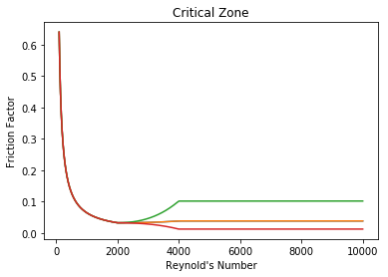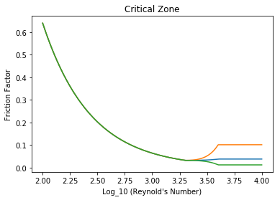

Swamee & Jain Model

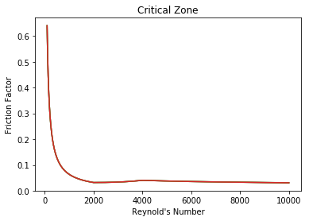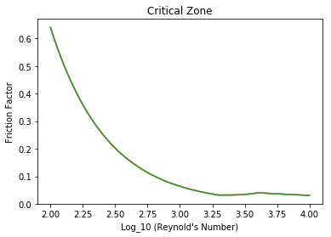

## Serghides

## C:\Users\Kevin Breslin\AppData\Local\Microsoft\Windows\INetCache\Content.Word\output_11_1.pngC:\Users\Kevin Breslin\AppData\Local\Microsoft\Windows\INetCache\Content.Word\output_11_2.png

## Dobromyslov C:\Users\Kevin Breslin\AppData\Local\Microsoft\Windows\INetCache\Content.Word\output_13_1.png

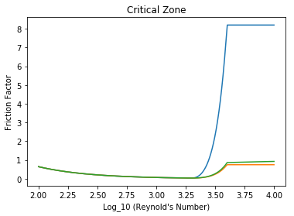

Goudar & Sonnad 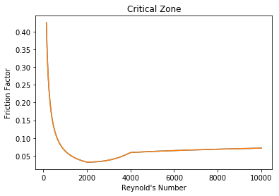

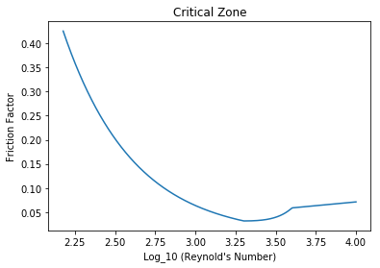

## Haaland

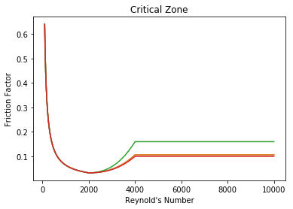

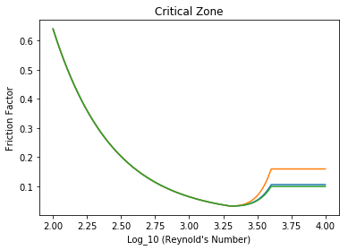

# Equations Used

***NB In these equations log is the decimal log log10 and ln is the natural log loge***

Moody Equation (1947)

$$f=0.0055\left(1+{\left(2∙{10}^{4}\left(\frac{k_{e}}{d_{int}}\right)+\frac{{10}^{6}}{Re}\right)}^{\frac{1}{3}}\right)$$

Wood Equation (1966)

$$f=0.094{\left(\frac{k_{e}}{d_{int}}\right)}^{0.225}+0.53\left(\frac{k_{e}}{d_{int}}\right)+88{\left(\frac{k_{e}}{d_{int}}\right)}^{0.44}∙Re^{-Ψ}$$

$$Ψ=1.62{\left(\frac{k_{e}}{d_{int}}\right)}^{0.134}$$

Eck Equation (1973)

$$\frac{1}{\sqrt{f} }=-2\log\left(\frac{k_{e}}{3.715d_{int}}+\frac{15}{Re}\right)$$

Churchill Equation (1973)

$$\frac{1}{\sqrt{f} }=-2\log\left(\frac{k_{e}}{3.715d_{int}}+{\left(\frac{7}{Re}\right)}^{0.9}\right)$$

Jain and Swamee (1976)

$$\frac{1}{\sqrt{f} }=-2\log\left(\frac{k_{e}}{3.715d_{int}}+\frac{5.74}{Re^{0.9}}\right)$$

Jain (1976)

$$\frac{1}{\sqrt{f} }=-2\log\left(\frac{k_{e}}{3.715d_{int}}+{\left(\frac{6.943}{Re}\right)}^{0.9}\right)$$

Second Churchill Equation (1977)

$$f=8{\left[{\left(\frac{8}{Re}\right)}^{12}+\frac{1}{{{(Θ}_{1}+Θ_{2})}^{1.5}}\right]}^{\frac{1}{12}}$$

$$Θ_{1}=\left[-2.457{\ln\left[{\left(\frac{7}{Re}\right)}^{0.9}+0.27\left(\frac{k_{e}}{d_{int}}\right)\right]}^{16}\right]$$

$$Θ_{2}={\left(\frac{37530}{Re}\right)}^{16}$$

Chen Equation (1979)

$$\frac{1}{\sqrt{f} }=-2\log\left(\frac{k_{e}}{3.7065d_{int}}-\frac{5.0452}{Re}\log\left(\frac{1}{2.8257}{\left(\frac{k_{e}}{d_{int}}\right)}^{1.1098}+\left(\frac{5.8506}{Re^{0.8981}}\right)\right)\right)$$

Round Equation (1980)

$$\frac{1}{\sqrt{f}}=1.8log\left[\frac{Re}{0.135Re\left(\frac{k_{e}}{d_{int}}\right)+6.5}\right]$$

Barr Equation (1981)

$$\frac{1}{\sqrt{f}}=-2log\left[\frac{k_{e}}{3.7d_{int}}+\frac{5.158\log\left(\frac{Re}{7}\right)}{Re\left(1+\frac{Re^{0.52}}{29}{\left(\frac{k_{e}}{d_{int}}\right)}^{0.7}\right)}\right]$$

Zigrang and Sylvester (1982)

$$\frac{1}{\sqrt{f}}=-2log\left[\frac{k_{e}}{3.7d_{int}}+\frac{5.02}{Re}\log\left(\frac{k_{e}}{3.7d_{int}}-\frac{5.02}{Re}\log\left(\frac{k_{e}}{3.7d_{int}}+\frac{13}{Re}\right)\right)\right]$$

$$\frac{1}{\sqrt{f}}=-2log\left[\frac{k_{e}}{3.7d_{int}}+\frac{5.02}{Re}\log\left(\frac{k_{e}}{3.7d_{int}}+\frac{13}{Re}\right)\right]$$

Haaland equation (1983)

$$\frac{1}{\sqrt{f}}=-1.8log\left[{\left(\frac{k_{e}}{3.7d_{int}}\right)}^{1.11}+\frac{69}{Re}\right]$$

Serghides equation (1984)

$$f={\left[ψ_{1}-\frac{{\left(ψ_{2}-ψ_{1}\right)}^{2}}{ψ_{3}-2ψ_{2}+ψ_{1}}\right]}^{-2}$$

or

$$f={\left[4.781-\frac{{\left(ψ_{2}-4.781\right)}^{2}}{ψ_{3}-2ψ_{2}+4.781}\right]}^{-2}$$

where

$$ψ_{1}=-2\log\left(\frac{k_{e}}{3.7d_{int}}+\frac{12}{Re}\right)$$

$$ψ_{2}=-2\log\left(\frac{k_{e}}{3.7d_{int}}+\frac{2.51ψ_{1}}{Re}\right)$$

$$ψ_{1}=-2\log\left(\frac{k_{e}}{3.7d_{int}}+\frac{2.51ψ_{2}}{Re}\right)$$

Mandilli equation (1997)

$$\frac{1}{\sqrt{f}}=-2log\left[\left(\frac{k_{e}}{3.7d_{int}}\right)+\frac{95}{Re^{0.983}}-\frac{96.82}{Re}\right]$$

Monzon, Romeo and Royo (2002)

$$\frac{1}{\sqrt{f}}=-2log\left[\left(\frac{k_{e}}{3.7{065d}_{int}}\right)-\frac{5.0272}{Re}log\left(\frac{k_{e}}{3.827d_{int}}∙\frac{4.657}{Re}\log\left({\left(\frac{k_{e}}{7.7918d_{int}}\right)}^{0.09924}+{\left(\frac{5.3326}{208.815+Re}\right)}^{0.9345}\right)\right)\right]$$

Dobromyslov Equation (2004)

$$\sqrt{f} =0.5\left(\frac{\frac{b}{2}+\frac{1.312\left(2-b\right)\log\left(\frac{3.7d_{int}}{k_{e}}\right)}{\log\left(Re\right)-1}}{\log\left(\frac{3.7d_{int}}{k_{e}}\right)}\right)$$

Where $b=1+\frac{\log\left(Re\right)}{\log\left(Re_{kv}\right)} for b≤2, for b>2, b is set to 2$

And $Re_{kv}=500\left(\frac{d_{int}}{k_{e}}\right)$

Goudar and Sonnad equation (2006)

$$\frac{1}{\sqrt{f}}=0.8686\ln\left[\frac{0.4587Re}{{\left(S-0.31\right)}^{\left(\frac{S}{S+1}\right)}}\right]$$

Where

$$S=0.124Re\left(\frac{k_{e}}{d_{int}}\right)+\ln\left(0.4587Re\right)$$

Rao and Kumar equation (2006)

$$\frac{1}{\sqrt{f}}=2\log\left(\frac{d_{int}}{2∙B∙k_{e}}\right)$$

Where

$$B=\left(\frac{a+b∙Re}{Re}\right)∙f(Re)$$

$$f\left(Re\right)=1-0.55e^(-.33{\left[\ln\left(\frac{Re}{6.5}\right)\right]}^{2}$$

$$a=0.444, b=0.135$$

Vatankhah and Kouchakzadeh equation (2008)

$$\frac{1}{\sqrt{f}}=0.8686\ln\left[\frac{0.4587Re}{{\left(S-0.31\right)}^{\left(\frac{S}{S+0.9633}\right)}}\right]$$

Where

$$S=0.124Re\left(\frac{k_{e}}{d_{int}}\right)+\ln\left(0.4587Re\right)$$

Buzzelli equation (2008)

$$\frac{1}{\sqrt{f}}=α-\left[\frac{α+2\log\left(\frac{β}{Re}\right)}{1+\frac{2.18}{β}}\right]$$

where

$$α=\frac{0.744\ln\left(Re\right)-1.41}{1+1.32\sqrt{\frac{k_{e}}{d_{int}}}}$$

$$β=\frac{k_{e}}{3.7d_{int}}Re+2.51α$$

**Goundar and Sonnad approximation (2008)**

$$\frac{1}{\sqrt{f}}=α-\left[\ln\left(\frac{d}{q}\right)+D_{CFA}\right]$$

Where

$$D_{CFA}=D_{LA}\left( 1+\left(\frac{\frac{z}{2}}{{\left(g+1\right)}^{2}+\left(\frac{z}{3}\right)\left(2g-1\right)}\right)\right)$$

$$D_{LA}=z\left(\frac{g}{g+1}\right)$$

$$z=\ln\left(\frac{q}{g}\right)$$

$$g=bd+\ln\left(\frac{d}{q}\right)$$

$$q=\frac{s}{s^{s+1}}$$

$$s=bd+\ln\left(d\right)$$

$$d=\frac{(ln\left(10\right)Re)}{5.02}$$

$$b=\frac{k_{e}}{3.7d_{int}}$$

$$a=\frac{2}{\ln\left(10\right)}$$

Avci and Kargoz

$$f=\frac{6.4}{{\left\{\ln\left(Re\right)-\ln\left[1+0.01Re\left(\frac{k_{e}}{d_{int}}\right)\left(1+10\sqrt{\frac{k_{e}}{d_{int}} }\right)\right]\right\}}^{2.4}}$$

Evangleids, Papaevangelou and Tzimopoulos

$$f=\frac{0.2479-0.0000947{\left(7-logRe\right)}^{4}}{\left[\log\left(\frac{k_{e}}{3.615d_{int}}+\frac{7.366}{Re^{0.9142}}\right)\right]}$$

Brkic solution based on Lambert W-function

$$\frac{1}{\sqrt{f}}=-2\log\left(\frac{k_{e}}{3.71d_{int}}+\frac{2.18S}{Re}\right)$$

Where

$$S=\ln\left(\frac{Re}{1.816\ln\left(\frac{1.1 Re}{\ln\left(1+1.1Re\right)}\right)}\right)$$

**Clamond Method**

Didier Clamond allows an iterative calculation of $λ$, which gives accuracy close to the limits of type double after two iterations. If requires calculation of logarithm once for initial estimation and one time per iteration.

$$f=F^{2}$$

Where

$$K=\frac{k_{e}}{d_{int}}$$

$$X1=0.123968186335417556K∙Re$$

$$X2=\ln\left(Re\right)-0.779397488455682028$$

$$F=X2-0.2$$

$$repeat 2 times\left\{\begin{aligned}E=\frac{(ln\left(X1+F\right)+F-X2)}{(1+X1+F)} \\ F=\frac{(F-\left(1+X1+F+0.5E\right)\left(X1+F\right)E)}{(1+X1+F+E\left(1+\frac{E}{3}\right)}\end{aligned}\right.$$

$$F=1.151292546497022842F$$

Dunlop cubic interpolation for $2000 <=Re≤ 4000$ 2000 <=Re<=4000

$$f=\left(X1+R\left(X2+R\left(X3+X4\right)\right)\right)$$

Where

$$Y3=-0.86859\ln\left(\frac{k_{e}}{3.7d_{int}}+\frac{5.74}{{4000}^{0.9}}\right)$$

$$Y2=\ln\left(\frac{k_{e}}{3.7d_{int}}+\frac{5.74}{{Re}^{0.9}}\right)$$

$$FA=Y3^{-2}$$

$$FB=FA\left(2-\frac{0.00514215}{Y2Y3}\right)$$

$$R=\frac{Re}{2000}$$

$$X1=7FA-FB$$

$$X2=0.128-17FA+2.5FB$$

$$X3=-0.128+13FA-2FB$$

$$X4=R(0.032-3FA+0.5FB)$$